**HOME WORK # 2**

**HCI Project**

*School Management System*

**Project Members**

* *Abdullah Tilal Khan 19k-1103*
* *Sadeem Sattar 19k-1102*
* *Salman Ahmed Khan 19k-1043*

**Shneiderman’s 8 Golden Rules**

1. Strive for consistency

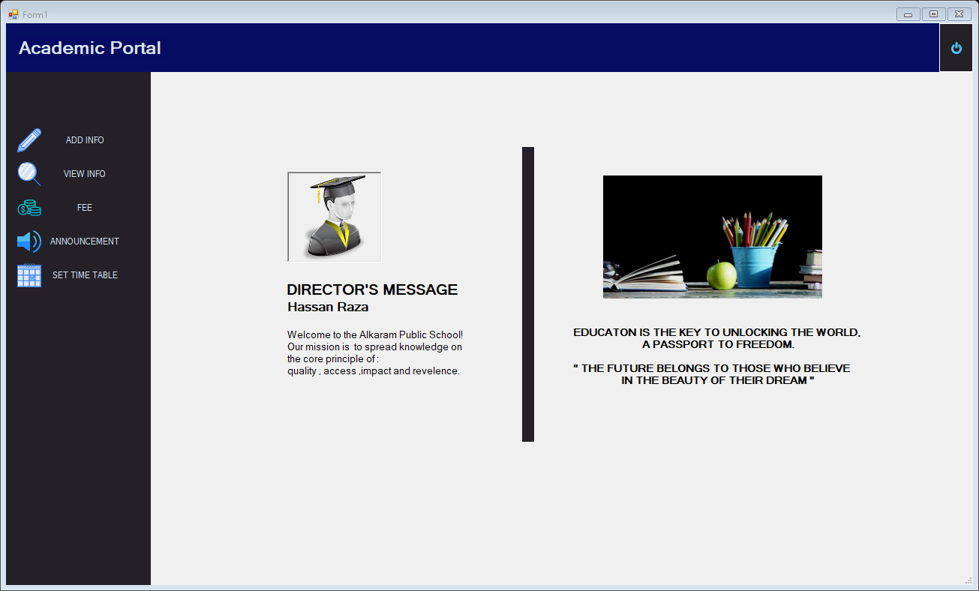

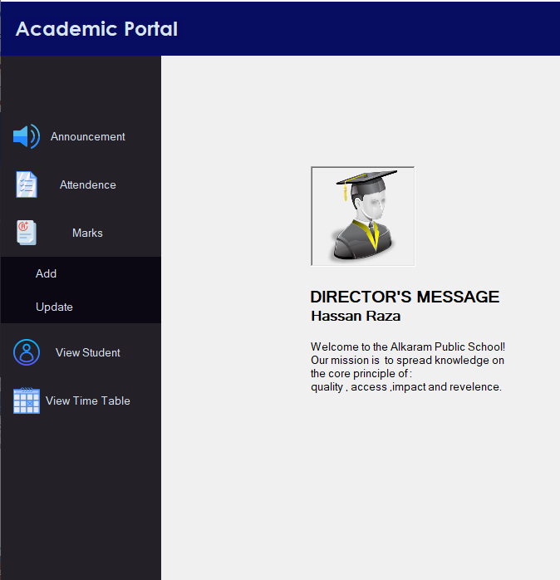

In the above screenshots, every form has the same layout around its borders. Especially along the header and left border. Such that in each form same type of panel is used along with the same design and color with having the same function as it has on other forms.

1. Enable Frequent users to use shortcut

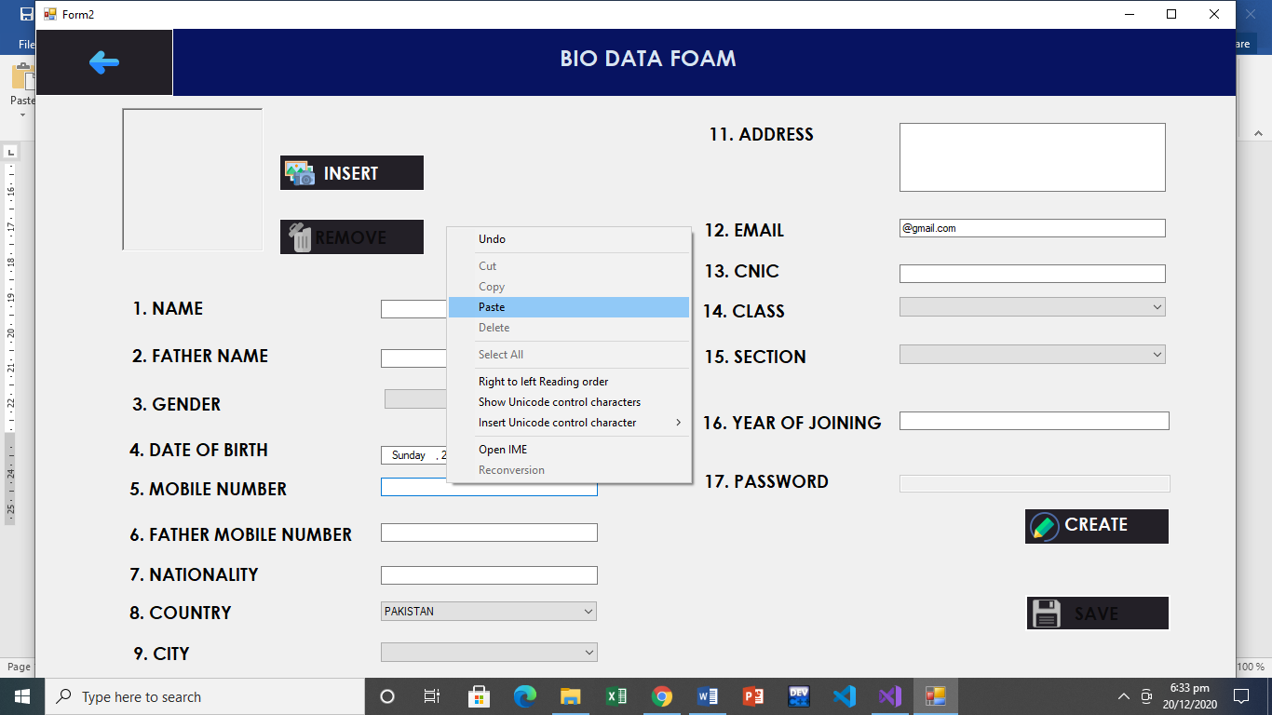

Here user is provided the ease to use shortcuts. Like user can use this dialogue to cut, copy and paste data in textboxes. In addition to he can use shortcuts like (ctrl + c) to copy, (ctrl + x) to cut and (ctrl + v) to paste.

1. Offer Informative feedback

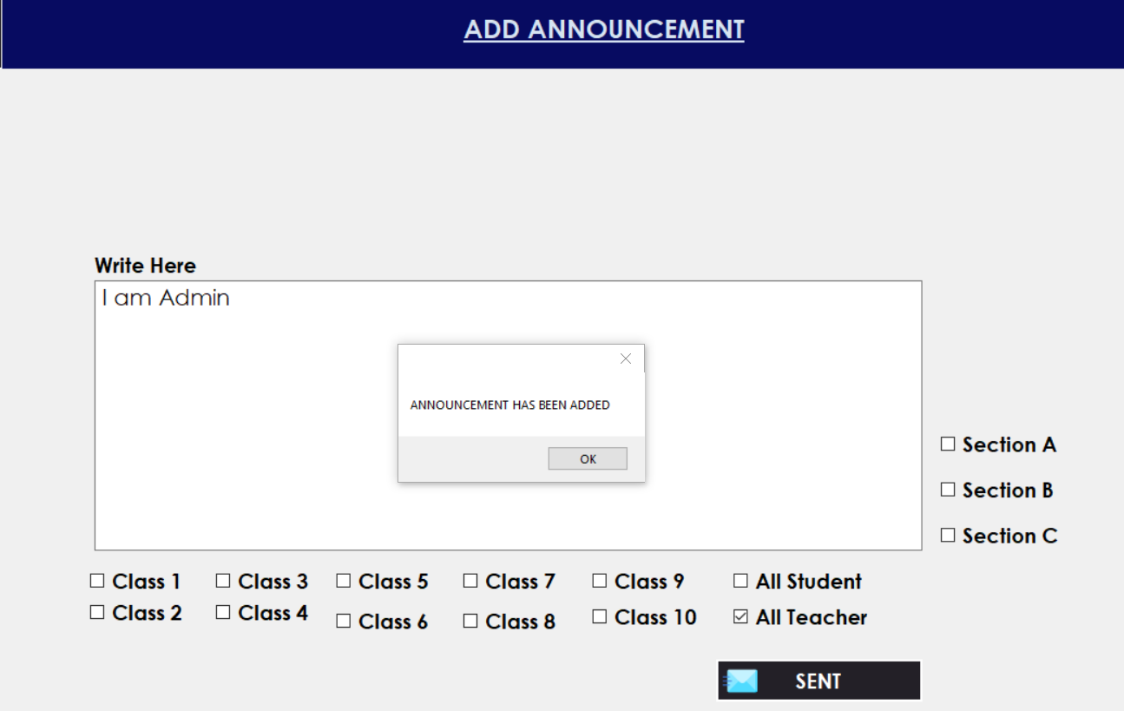

In the above screenshot, concept of informative feedback is applied in such a way that when an announcement has been written by the user and then he clicks on “sent” button, A message box pops up which informs the user that his announcement has been successfully added for the desired students or teachers.

1. Design dialogs to yield closure

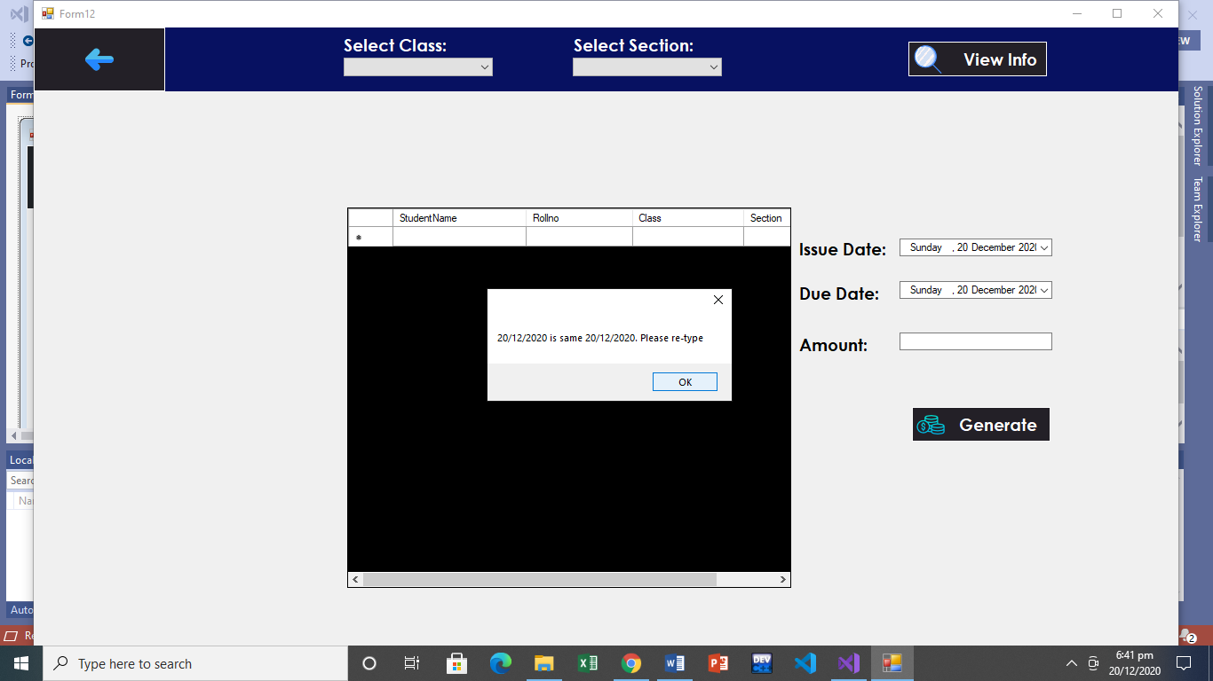

In the above example, while generating a fees challan, user will not be able to generate challan successfully until he did not input due date other than current date. Either he enters the due date other than current or go back to home page.

1. Offer simple error handling

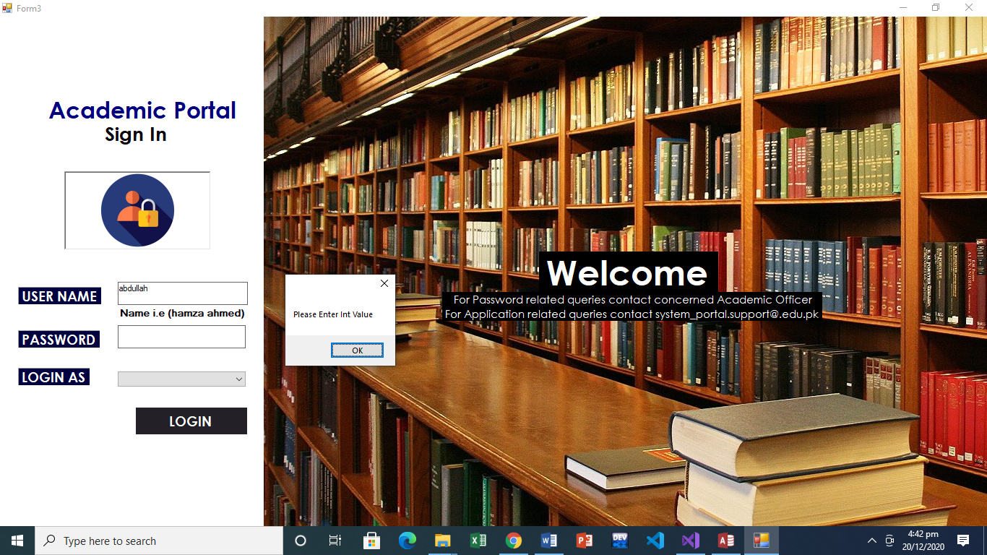

Error handling is done in the above screenshot in such a way that whenever user tires to login and input wrong password such as any character other than number, then user is not allowed to enter it and an error message is shown in which user is asked to enter only integer values.

1. Permit easy reversal of actions

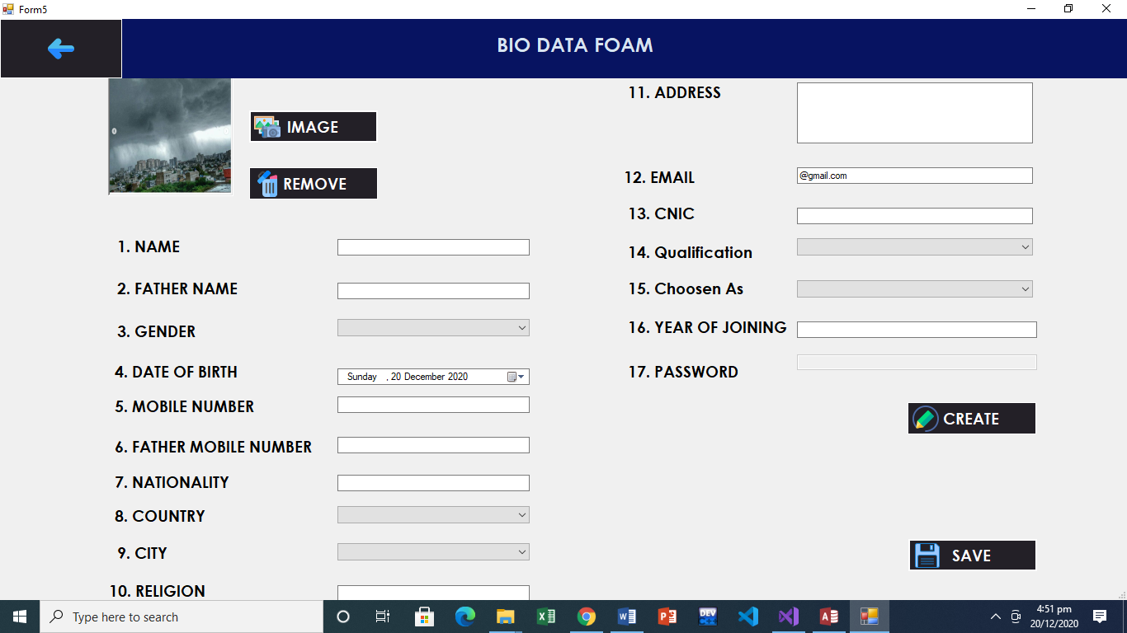

In the above screen shot, concept of easy reversal of actions is applied in such a way that if user has selected a wrong image then he can reverse this selection by clicking on the “remove” button to remove image and then select a new image.

1. Support internal locus of control

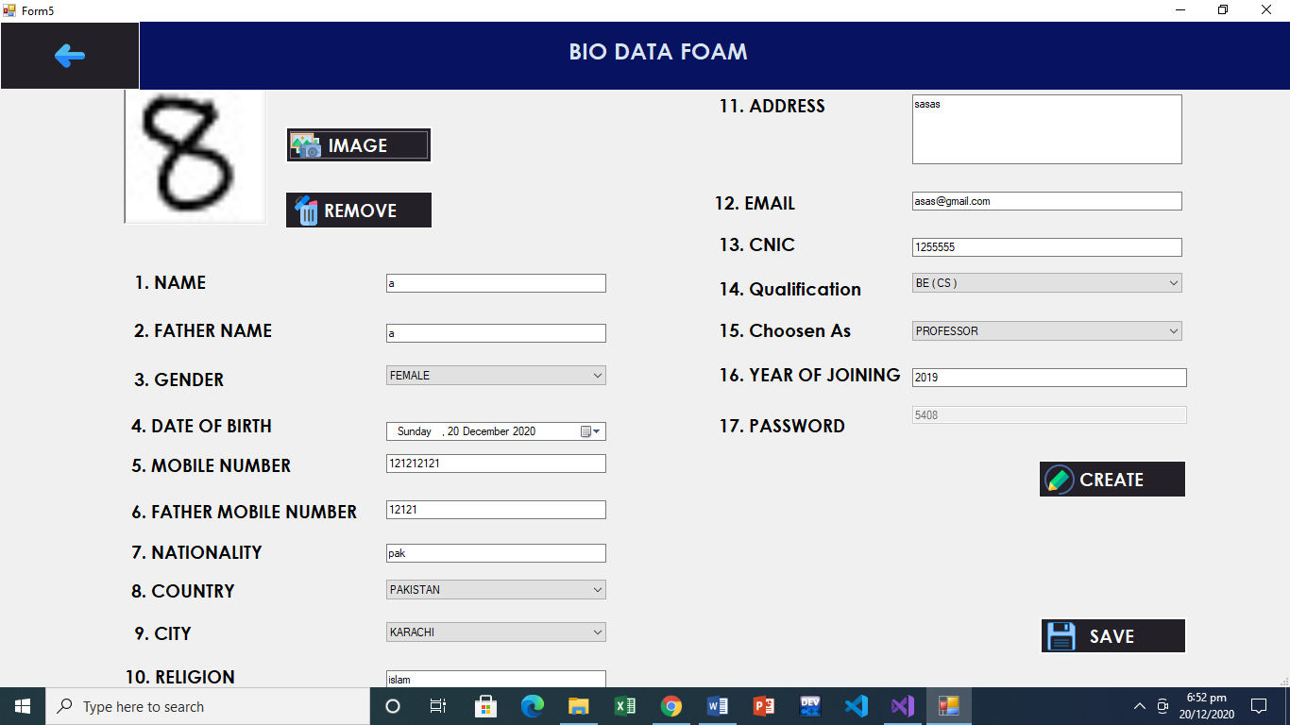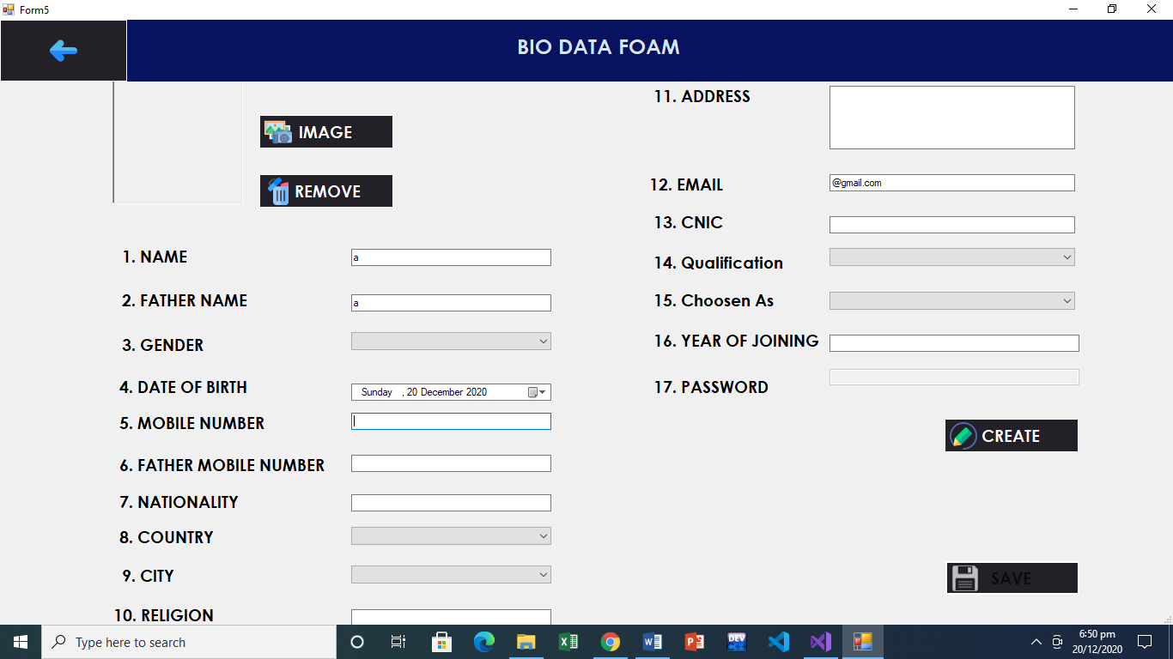

In this example, save button is not clickable as user has not entered data in all fields. But when all data fields are filled, then save button becomes clickable and it’s been shown as change in the color. Thus it supports internal locus of control.

1. Reduce short term memory load

In the above screenshot, we have used real life metaphors as icons as a result user will not have to remember what the functionality of each button but by metaphors he can easily map the functionalities with real life thus he will not have to recall but recognize. Thus reducing the load on short term memory.

**Norman’s 7 Principles**

1. 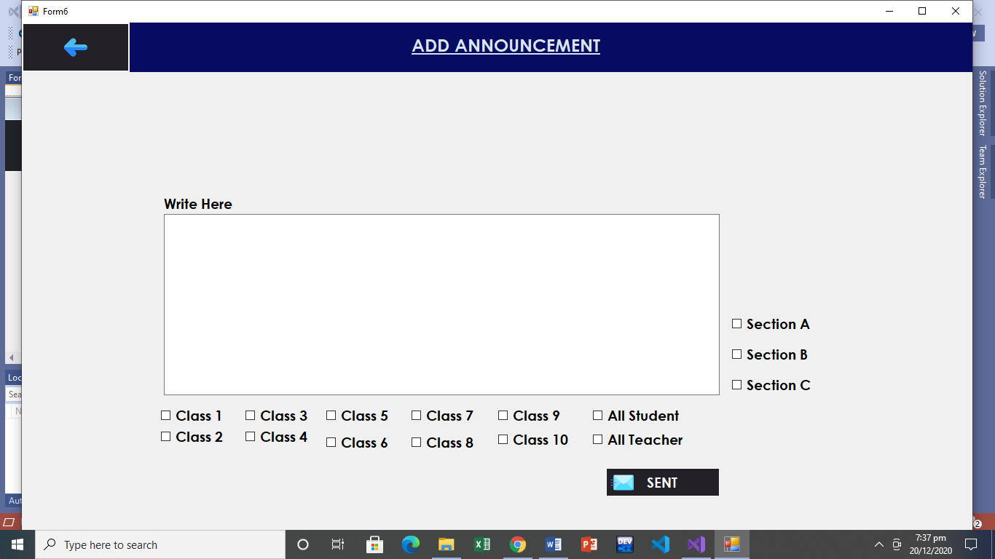Use both knowledge in the world and knowledge in the head

We tried to bring this concept with the help of metaphor. Here in this example we have used envelop as a metaphor for the sent button because by looking at envelop one thinks of sending something so user will relate real world knowledge with this sent button to send announcements. In addition to, most of the cell phones use envelope icon as metaphor so user will also have some knowledge and relevance with it.

1. 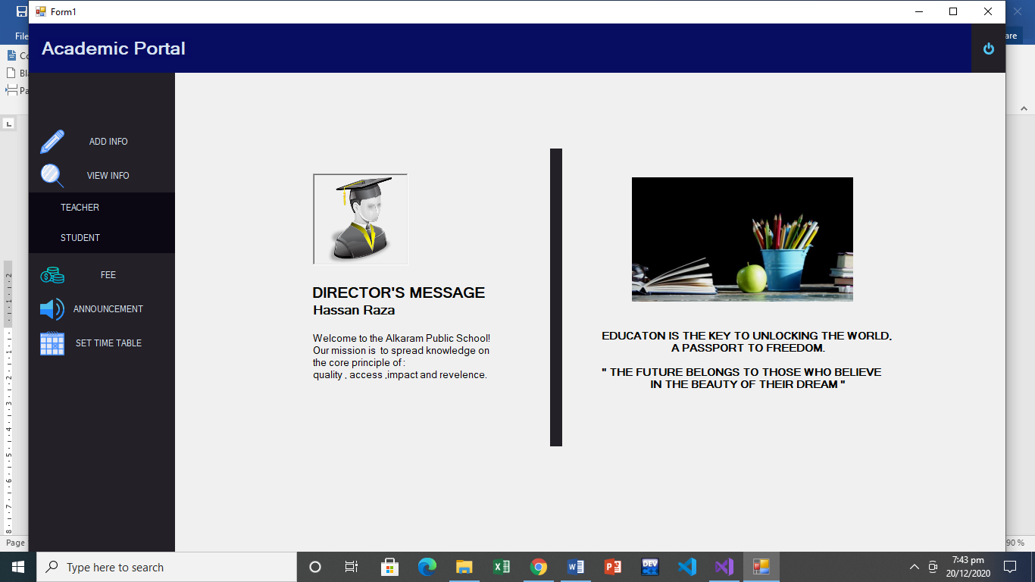 Simplify the structure of tasks.

Here the task of viewing info simplified in such a way tha whenever user wants to view info,he will click on the view info button.Then he has shown more options to select from which than take him to the relevant viewing info form.In this was this task has been simplified rather than providing all the options available on front which will confuse user and makes the app feel crowded.

1. Make things visible: bridge the gulfs of Execution and Evaluation

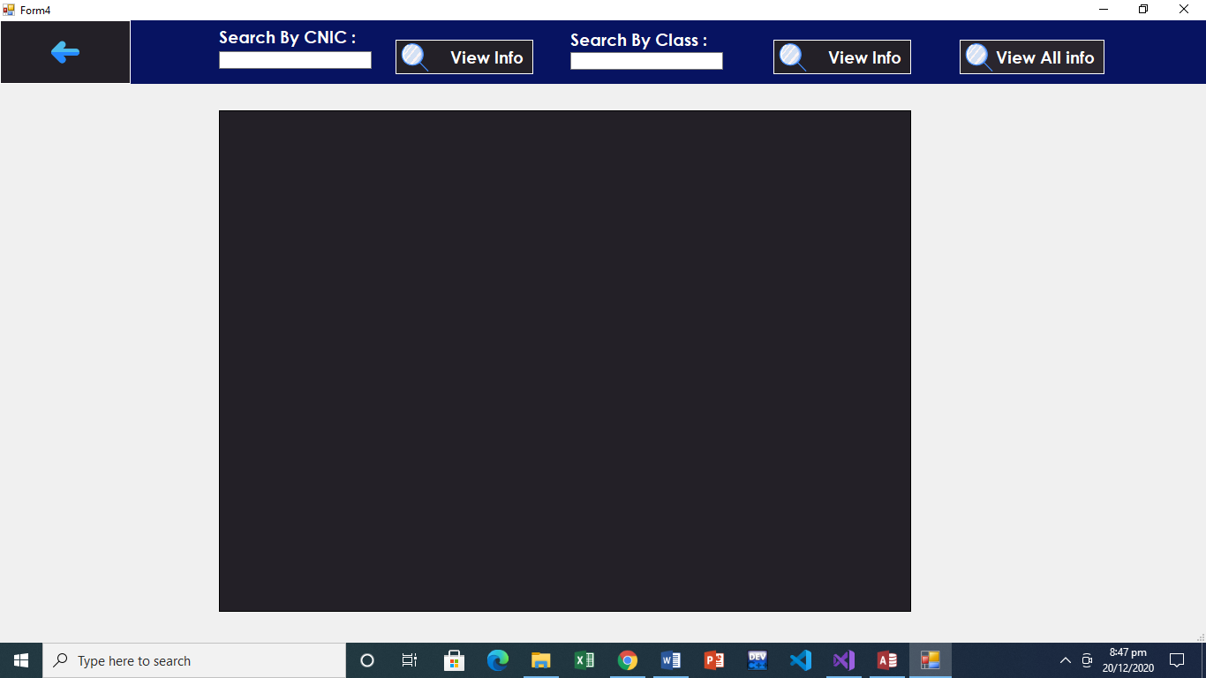

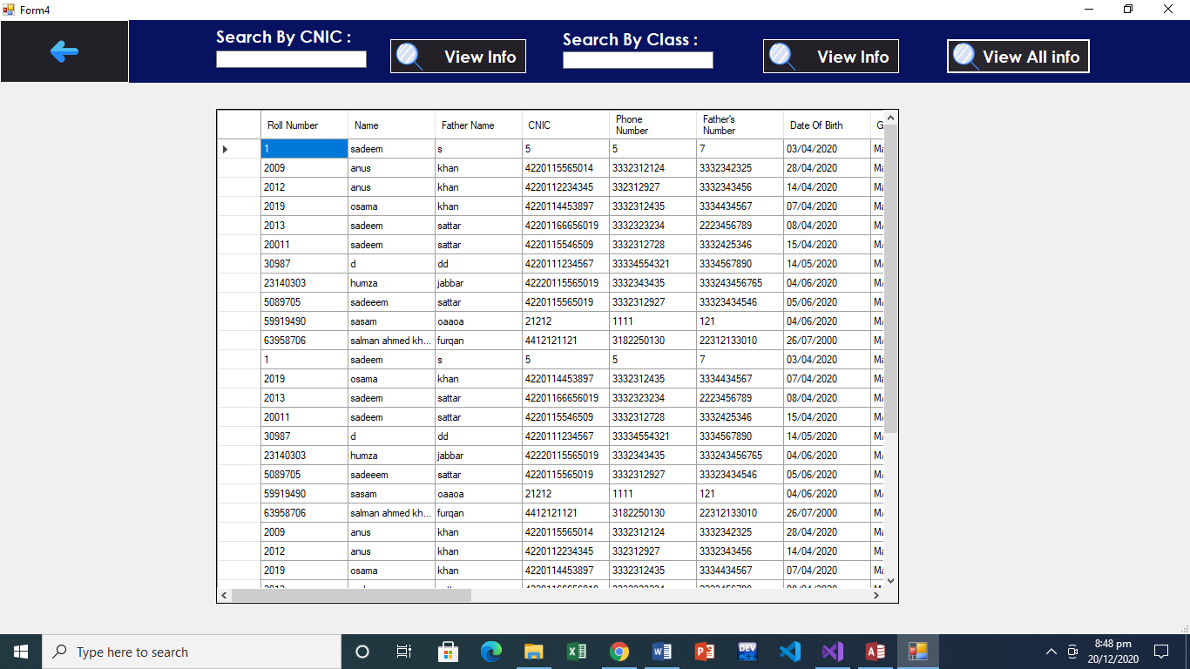

Here the gulf of execution and evaluation has been reduced in such a way that when user wants to view information ,he will click on view info button as shown in first screenshot.And as he presses the button,relevant information will be displayed on the datagridview in result of the action executed by the user to evalute the result as shown in second screenshot.

1. Get the mappings right

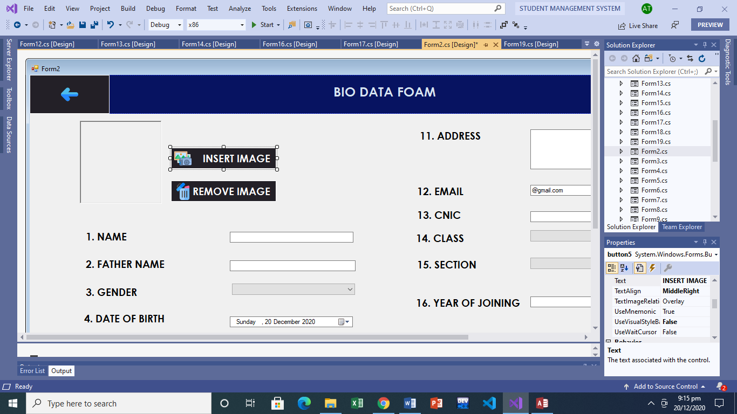

Here in this screenshot, all the functionalities related to the insertion of profile picture are grouped together and metaphor is also used. Insert button is stacked over remove button because first user would like insert image and then in case of wrong selection he will get to use the remove button.in this way we tried to do mappings right of these functionalities using buttons.

1. Exploit the power of constraints, both natural and artificial.

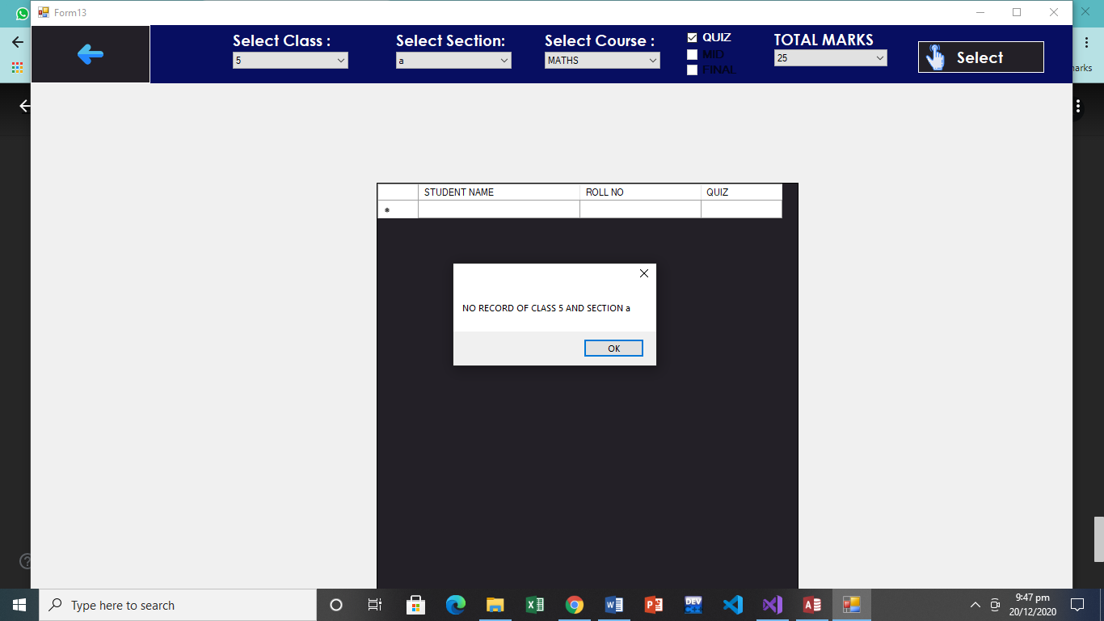

Here in this example, Updating marks will not be a valid operation until marks are not added by teacher previously. And in this case a message box will popup that shows that no previous data is found. In such a way there is only one way to update marks that is if already marks has been added by a teacher.

1. Design for error

In this screenshot it’s explained that during the designing of this form, it was considered that user may enter wrong password. As result to prevent this, checks has been added that inform user that wrong password was entered by them via message box. And that they are restricted to enter wrong input.

1. When all else fails, standardize

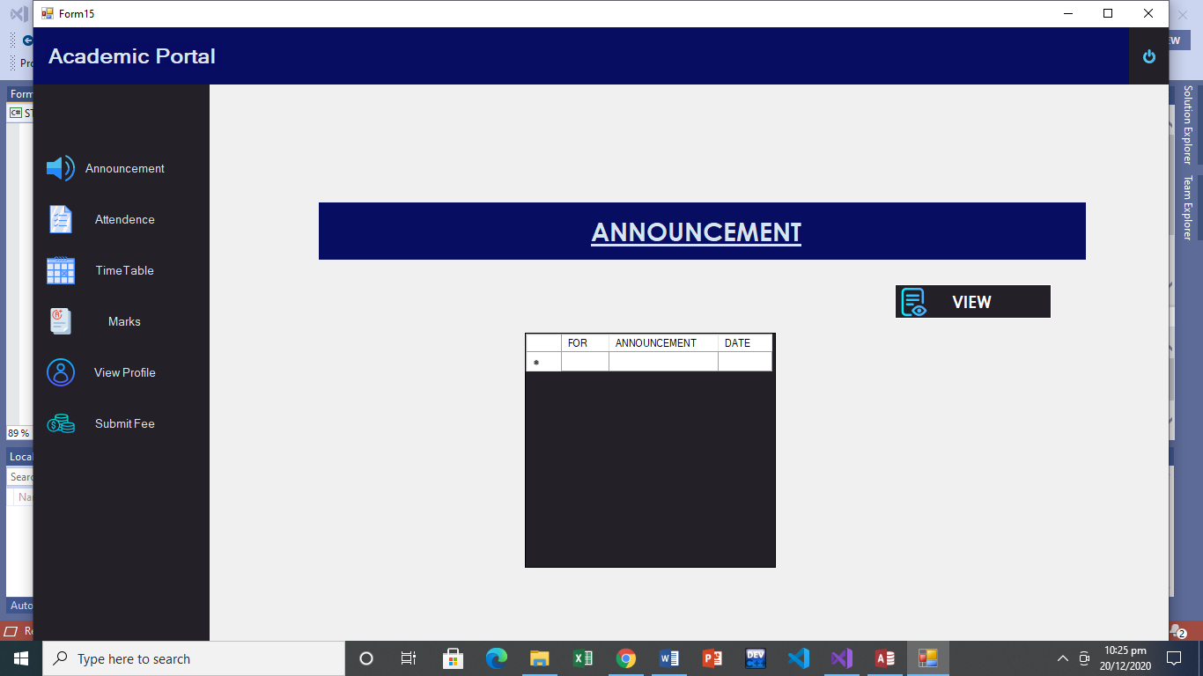

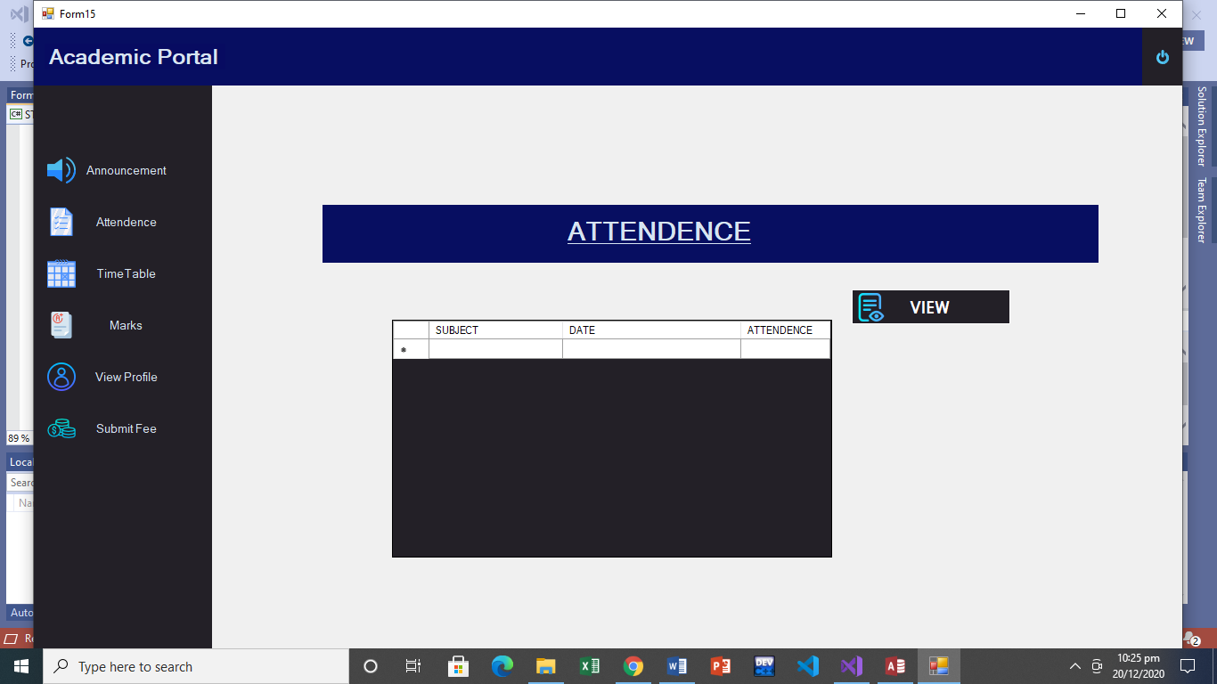

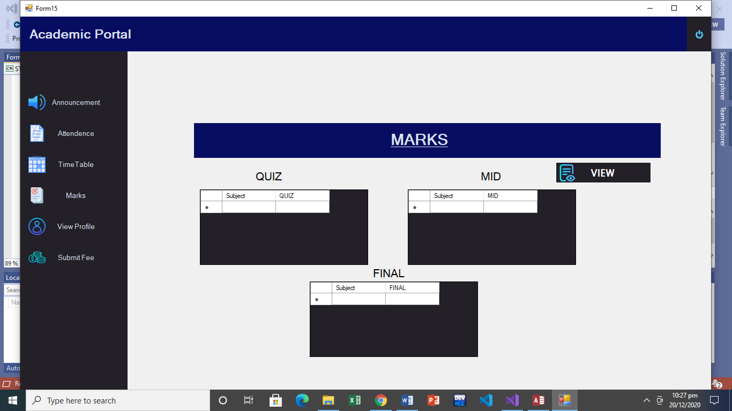

When user will not be familiar with the system, he might have some problems in understanding the system. But once he learn it, he will be able to apply this knowledge everywhere in the app as shown above. Here he can apply the knowledge learn from viewing announcement to other forms such as view marks and attendance.

**DESIGN RATIONAL**

* The model used is QOC
* The questions are written and below them in bullet point Options are available corresponding with their criteria which include either pro or cons and their brief details.

What will be the color contrast?

* Negative contrast: Easy for user to view the windows form and effective user display.
* Positive contrast: Every items and elements in form will look similar and difficult for user to differentiate.

Contrast Selected: Negative contrast. 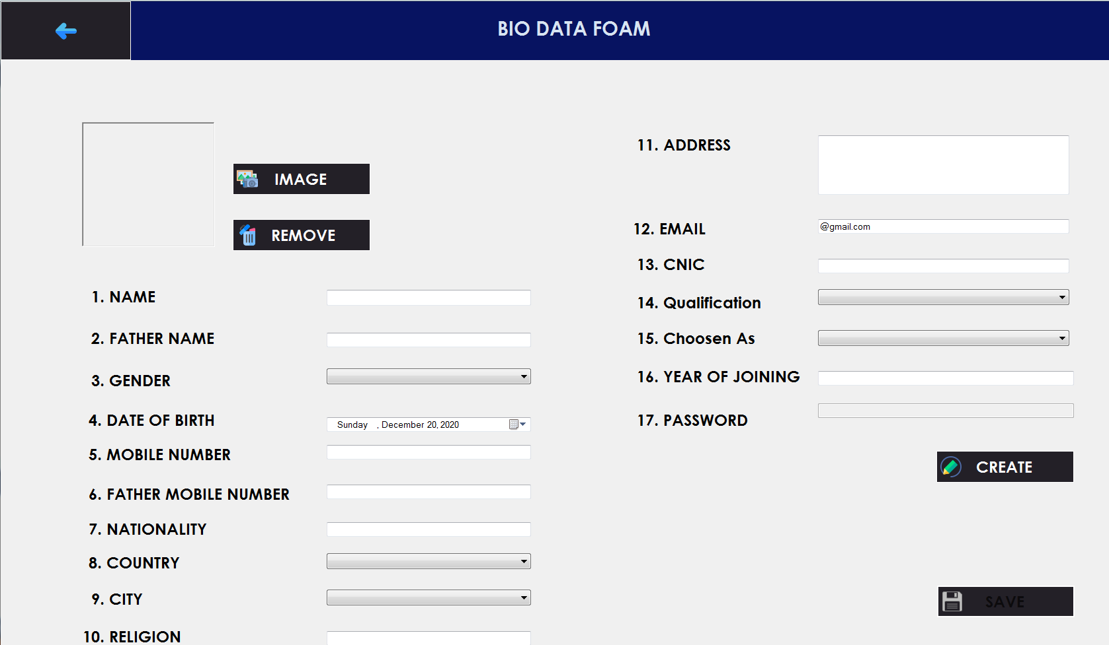

What is the button will look like?

* Rectangle form: Easy for user to click on the button and reduce the time of the user in order to drag the mouse and click.
* Circular form: Minimize the space on the windows form and maximize the user time in order to drag the mouse and click.

Button Selected: Rectangle form

How the main menu will be presented to the user?

* Horizontal Menu Panel: All the functionalities will be placed on the panel horizontally thus create horizontal menu panel. The more functionality, the more compressed look. Also, user might get distracted from it
* Vertical Menu Panel: All the functionalities will be placed on the panel vertically thus create vertical menu panel. It creates effective display of menus and when clicking on the buttons on the panel, a new page will open which create nice view.

Menu Panel Selected: Vertical Menu Panel

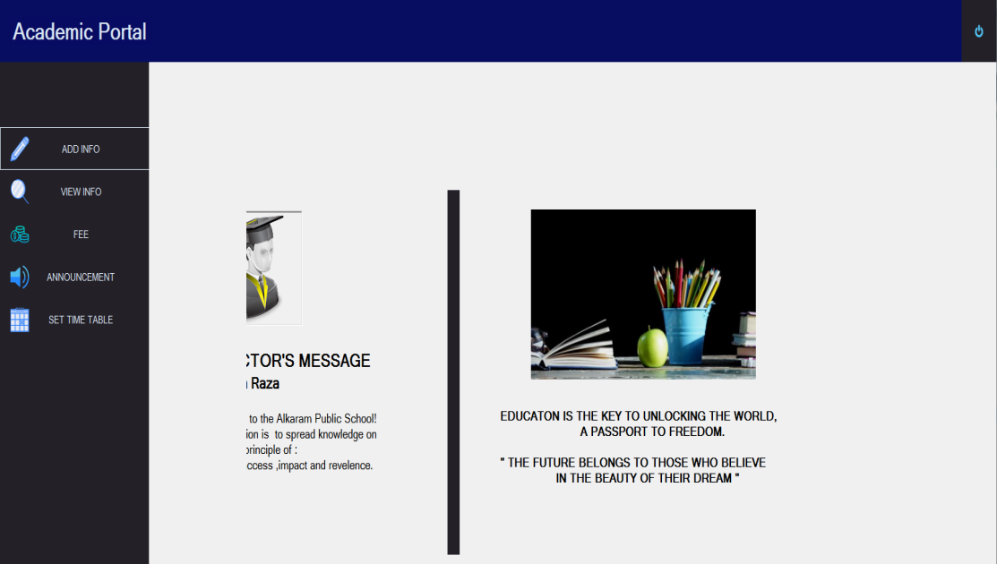

How the font of the text will be?

* Different text fonts: Every font of the text on the individual form will be different from others which will create uniqueness. Also, it will distract user and its interaction will be poor.
* Same text fonts: The fonts of text throughout the system will be consistent which will impact user satisfaction and interaction will be increased.

Font text Selected: Same text fonts



How the user will log in the system?

* Name: It will be unauthenticated to log in the system and security will not be held.
* User name, password and user selection: A particular user name and password will be given to every user and user will select of its option (i.e. Admin, Teacher, Students). Also, security will also be maintained through it and no one can log on anyone else system.

Login Criteria selected: User name, password and user selection.

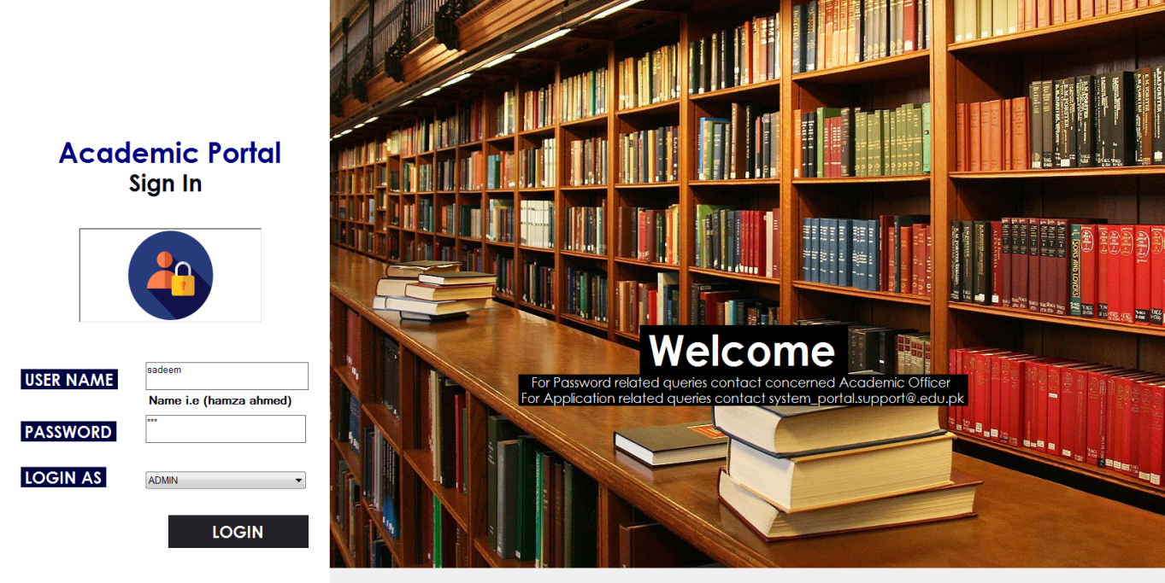

How the Admin will input the information of teacher and students?

* Text box only: The admin can input the information in text box. The user will have to remember what to write and what information is to be saved. It will be time costly and non effective.
* Form based system: The admin can input the information as per the available label and criteria to enter the correct information. The form will include some text box and drop box menus which will be easy to write the information. It will be effective for user.

Input the information selected: Form based system



How the announcement will be added by admin and teacher?

* Pre-defined text selection: A menu box will be given to user in which predefined announcements will be available through which user can select and send to others. This will bound the user and it can not enter any new announcement.
* Textbox: A text box will be presented in which user will enter whatsoever announcement the user want to add and display to the other users. This will give user free to post any announcement and bound it.

Announcement add selected: Text Box

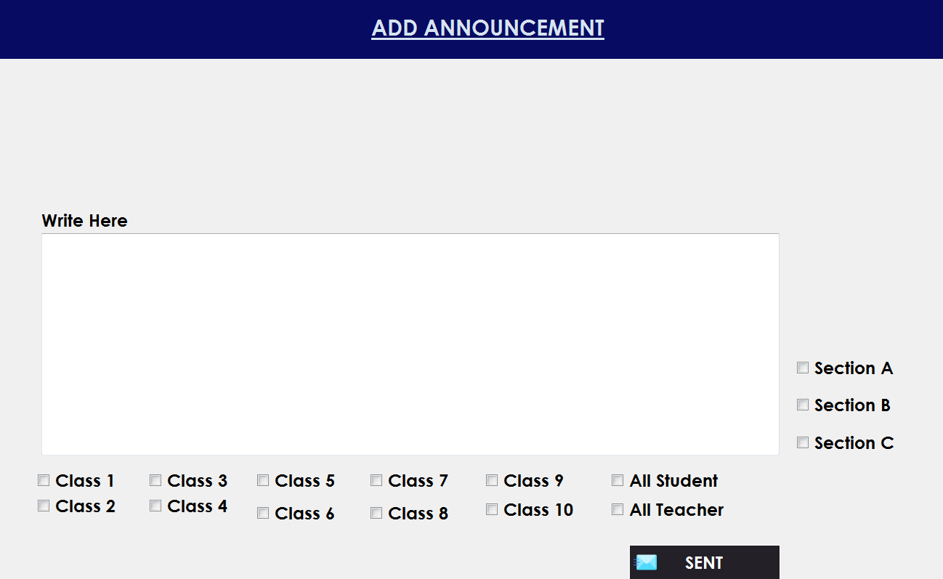

How the Fee challan will be generated?

* Type individual student name and amount in textbox: The user will enter the student name and amount in a textbox through which challan will be generated. It will be time consuming as the user will have to enter every student name and amount of the whole class. Also, user will be needed to do recall remembering whose fee has been generated.
* Select class and section (selection box): The user will select the class and section whose fee is needed to be generated. On selecting, every student detail will be shown. The user will only need to recognize and enter the amount. This is effective as the user can generate the fee for whole the class once.

Fee generation Selected: Selection box

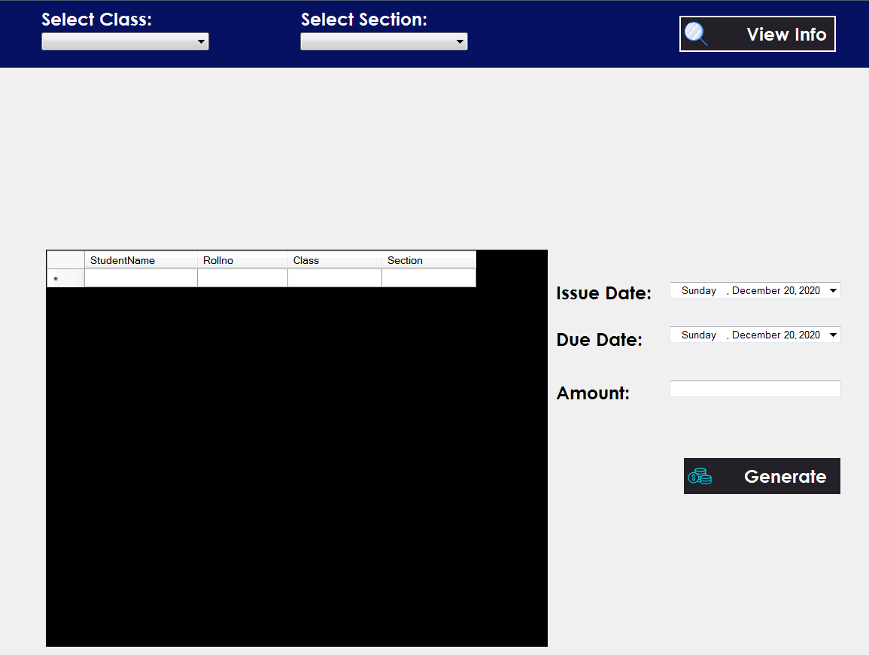

How the timetable will be added?

* Textbox: The user will type the teacher name, class, section, class timing and subject manually in order to add the announcement. This will be time costly and user will have to remember everything.
* Selection box: The user will be presented with the selection box through which user will select the entries. This will be effective and user will have to recognize rather than recall every class name, timing etc.

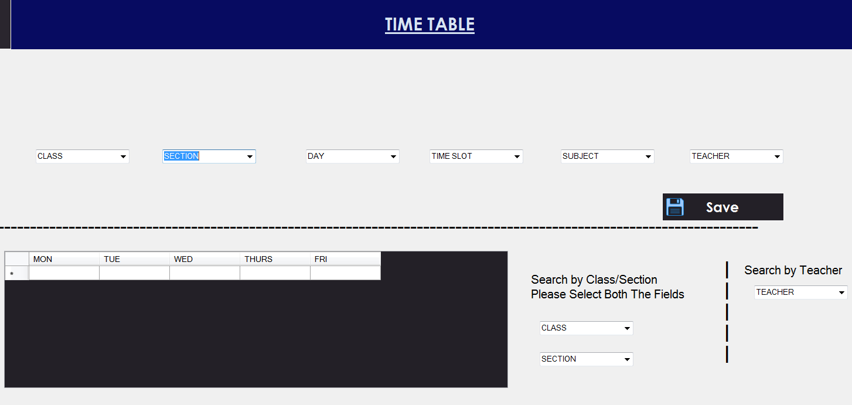Selected: Selection box

How the user (teacher) will add the attendance of student?

* Select individual: The user will have to select every individual student name and then mark the attendance. This will require user to do the task multiple time and the interaction will be poor.
* Select class and section: The user will only select class and section and all the student name and attendance will be displayed simultaneously. The user will only look the student name and mark the attendance of every student. This will reduce user time and the interaction between user and system will become interactive.

Selected: Selection of class and section display

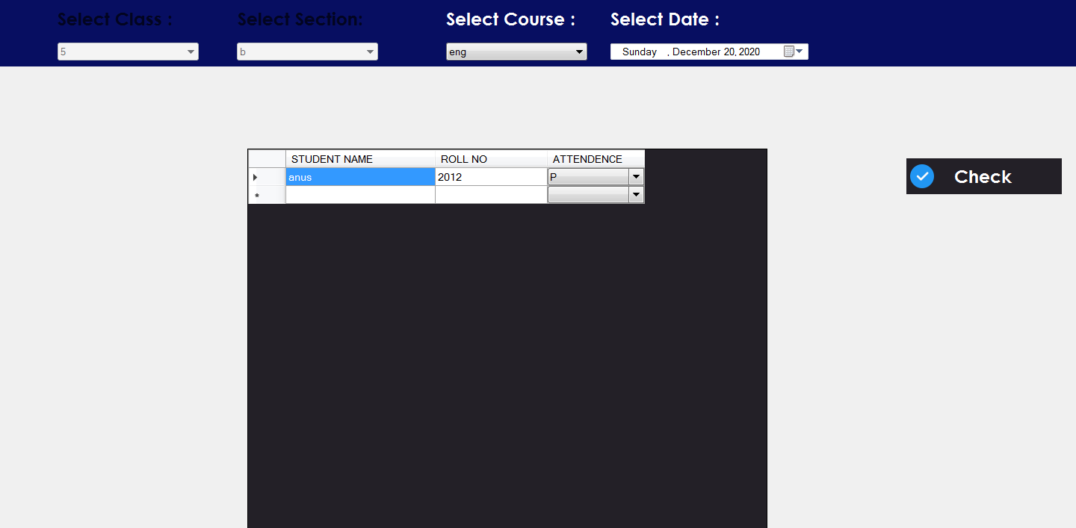

How the user (teacher) will mark the marks of student?

* Select marks range: The user will select the predefined marks from selection box and the exam type, thus add the marks of the students. This will bound the user to select from a range and user will not be able to mark specific marks.
* Type marks: The user can add marks of every individual student. This will allow user to enter the specific marks and user can freely add the marks.

Selected: Type marks

